|  |  |  |  |
| --- | --- | --- | --- |
| **Appendix J: Prototype Testing** | 50 |  |  |
| Are the areas of greatest uncertainty identified | 10 | identified most of the relevant areas of uncertainty, but missed one important area or included minor irrelevant areas | All relevant areas clearly identified |
| Are the proposed tests appropriate? | 10 | Tests are generally appropriate. Expanded and more comprehensive testing likely required | Proposed tests are appropriate and comprehensive |
| Are the pass/fail criteria clearly articulated? | 10 | listed but without complete explanation | clear and complete listing of criteria and associated explanations |
| Does the forecast include all major costs? | 10 | generally complete with minor error or omission | substantial with no errors and all relevant costs considered. |
| Is there a reasonable estimate of the timeline | 10 | generally complete with minor error or omission | substantial with no errors and all relevant costs considered. |

* Include things outside of engineering analysis (parts unable to theoretically quantify, or are out of our scope, but may be important for overall structure and completeness of system)
* Research ways to test these parts, how long they will take, how effective, how much do they cost

Certain components/subsystems of our TrailRider are deemed out of our project scope for analysis due to time constraints, and so we did not calculate, quantify, or analyze these parts. Yet among these out of scope parts, we have identified some that are still important for proper end product performance. For these, we have decided to verify and validate using prototype testing. From our requirements, we have identified the ergonomics and durability requirements to be out of our analysis scope. From our DFMEA, we identified that fatigue of parts, ~~and foreign projectiles~~ were the most occuring and uncertain risks (ie. they showed up the most and we didn’t do analysis on it).

Ergonomics states that “the device comfortably seats a parpalegic rider for a minimum of 2 hours”. We will test this by building a prototype of the seat configuration and lever propulsion by using a standard wheelchair and a double pronged L-bar/pipe on either sides equipped with weights on the bottom end. See figure below for a sketch of this lever prototype. These L-bars/pipes mimic our TrailRider’s lever propulsion at a low cost, and can be easily moved to test the most ergonomic lever placement. Parapeligic volunteers will test a lever placement of the seat configuration for 2 hours, and alternate to the next lever placement the next day. This will go on until all the lever placements have been tested by each volunteer. The volunteers will rank and comment on each lever placement,and we can analyze these results for the most ergonomic lever placement. The volunteers are also welcome to comment on the seat configuration, if any improvements from a standard wheelchair seat are needed. Testing is expected to occur for a week, and we aim for about 50 volunteers, with one prototype. Multiple volunteers will be scheduled to test each day, and availability will vary greatly so this area has lots of uncertainty. Alternatively, we could produce multiple prototypes and test in a smaller duration. Overall, this prototype testing will cost approximately:

* $40 a week for a rental wheelchair
* $20 for two lever prototypes (plastic)
* $10 for strap on weights

This totals to $70 to prototype test for ergonomics.

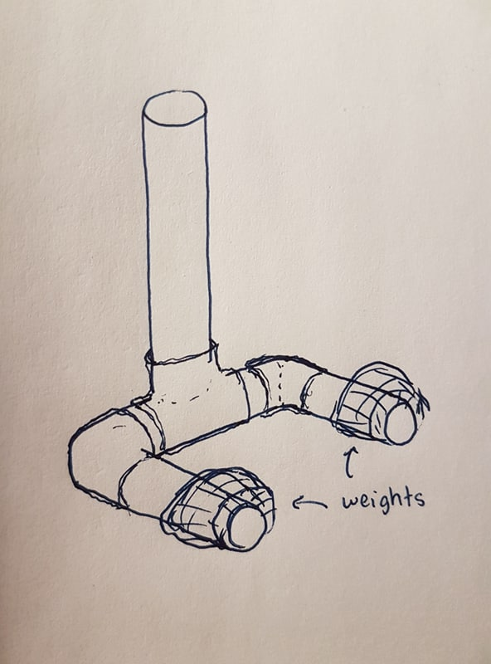

The durability requirement “the device has a predicted service life of at least 10 years with regular maintenance” aligns with the fatigue risks from our DFMEA. We will test the driven and driving shafts and lever in fatigue because these were parts out of our engineering calculations scope, and are identified to be at risk of fatigue. It is also quoted as good practice to test parts for fatigue. This can be done using full size prototype of the shafts complete with notches if needed, and full size lever. The shafts will be subjected to a rotational cyclic loading, and the lever subjected to cyclic bending load. The parts will be reconfigured as results suggest. The cost will approximately be in thousands of dollars because of the fatigue test machine, but if we were to rent the test machine or borrow UBC’s the cost will greatly reduce to hundreds of dollars. On average, testing machines cost about $5000. For renting, we can approximate 1/50th of this per hour, so $100 per hour. The duration of test will be pretty short (in a matter of hours) considering fatigue test machines can operate at very high frequency. We will approximate the duration for testing to be 5 hours maximum. Add this to the $70 for the parts cost, and this totals to $570 for testing fatigue-able components.

Another prototype testing we plan to do is for the frame. Our main concern is the integrity of the of the frame as it is made of Steel and no calculations could be done on its geometry in the time given. We will do a simple static load test on a full size frame prototype by adding weights on top. Since we are modelling for the TrailRider, this new frame should also be able to carry the maximum weight capacity of 108 kg. The cost to manufacture the frame should be around a few hundred dollars, estimated from bike frames. The testing would occur within a day. The frame costs $780 to manufacture, and taking the $100 per hour approximation of renting an engineering machine from fatigue testing above, and testing for an hour. We get a total of $880 to test the frame. Assuming we only do one iteration.

It will also be necessary to test a full scale prototype of the complete design before product release for final verification and reliability. This cost should equal the total production cost for the final product, plus any additional testing costs not yet in the scope of this analysis. After verification, we can test for other device specifications such as mechanical efficiency and final weight limit with the full scale complete prototype.

|  |  |
| --- | --- |
| **Prototype Test** | **Cost** |
| Ergonomics | $70 |
| Fatigue Test | $570 |
| Frame | $880 |
| Total | $1520 |

Reference

* <https://www.abbeymedicalsupplies.com/rentals> (wheelchair rental)
* <http://www.streetsie.com/trailrider/> (existing TrailRider weight capacity)